TonyBet Casino - Ontario Review 2026
Affiliate disclosure: OntarioGamers.ca earns commission when you sign up through our links — at no extra cost to you. This, however, does not influence our editorial recommendations.

TonyBet Ontario Casino
Overall rating | 8.6/10
License | ✓ AGCO  ✓ iGaming Ontario (OPIG1239101)
Minimum deposit | $10
Deposit methods | Visa, MasterCard, MuchBetter, Interac e-Transfer
Withdrawal time | 12 hours - 7 days
Established | 2023
Play Now at TonyBet Ontario
19+ | Ontario Only | Play Responsibly
TonyBet Casino joined Ontario iGaming in 2023. But the brand's roots date back to 2003 when it was known as Omnibet. It's only after Australian poker player Tony G rebranded it to TonyBet in 2009 that the brand went global. Today, this Latvia-based powerhouse is a triple threat, offering online casino games, live games, and sportsbetting – all accessible to Ontario players under a single account.
From the moment you land on TonyBet Casino Ontario, the bright white layout with purple and orange accents makes you feel like you’ve landed on a modern casino on the strip, but without the flashy bells and whistles. The casino features a library of 2,500+ online casino games from the best providers – Pragmatic Play, Hacksaw Gaming, and Evolution, to name a few. While slots make up the bigger chunk of the games lobby, a strong live casino offering and a few software-based table games are also available.
Curious about what sets this AGCO and iGaming Ontario licensed online casino apart? Read our in-depth TonyBet Ontario Casino review to learn what it does well and where it falls short.
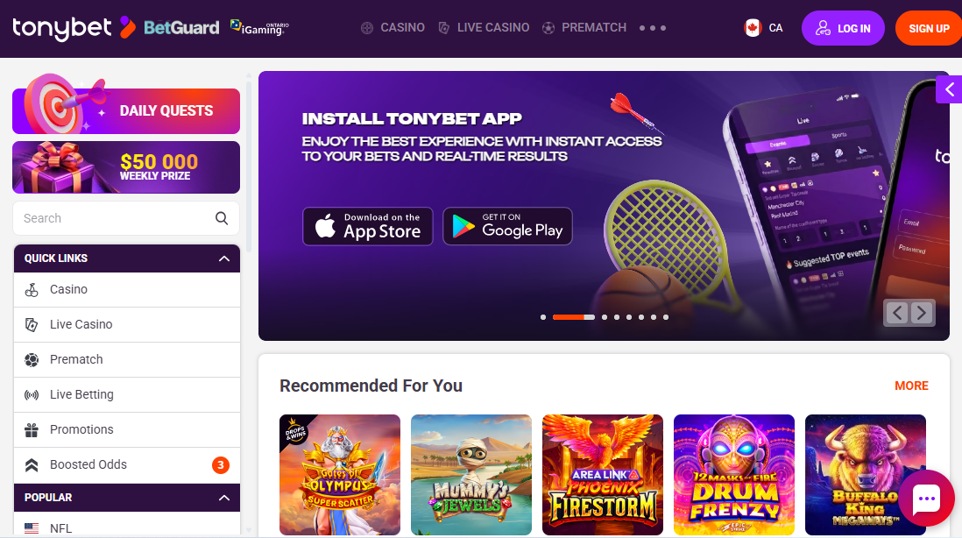

First Impression: A Global Brand with a Refreshingly Clean User Interface
Although TonyBet Casino gained international acclaim following its acquisition by world-famous poker pro Antanas ‘Tony G’ Guoga, TonyBet Ontario offers no peer-to-peer poker rooms or tournaments.
What you’ll find instead is a mix of slots, live casino titles, alongside select RNG tables, all well-organized in a simple layout with straightforward menus, helpful filtering options, and fast-loading pages. Add this to the brand’s positive reputation across more than 20 years, and it’s easy to see why the platform is known for its overall quality and reliability.

TonyBet Ontario Casino Overview

Parent Company Name | Ligtip Limited
License number | OPIG1239101 (AGCO, iGaming Ontario)
Number of games | 2,500+
Types of games | Slots, table games, live dealer games
Minimum deposit | $10
Minimum withdrawal | $10
Payout speed | 12 hours to seven days
Mobile apps | Yes (Android, iOS)
Customer support | FAQ; live chat; contact form; email (info@tonybet.ca)

TonyBet Ontario Casino Pros & Cons
Pros | Cons
- Trusted name with more than two decades of experience | - No specific tab for software-based table games
- A growing collection of over 2,500 casino games from 41+ major providers | - Offers a small pool of banking methods
- Dedicated iOS & Android apps for gaming on the move | - Lacks phone support
- Offers casino games and sports betting under a single account | - Modest app ratings
- Instant Interac deposits and under 24-hour withdrawals

TonyBet Ontario Casino Games and Software
It’s not the size of the TonyBet Ontario Casino game library that impresses. At 2,500+ games, it’s on par with NorthStar Bets Casino Ontario (2,800+) but much larger than giants like Jackpot City Casino Ontario (1,600+) and All Slots Casino Ontario (1,300+).
The real draw lies in the quality and structure. Beyond offering Ontario favourites, the smooth filtering options and clear game categorizations make it easy to browse through the massive game collection.
Notably, 41+ game studios power this platform; the likes of Elk Studios, Games Global, NetEnt, and Thunderkick. Let’s take a closer look at the available games:

Slot Games Selection - What Sets This Casino Apart?
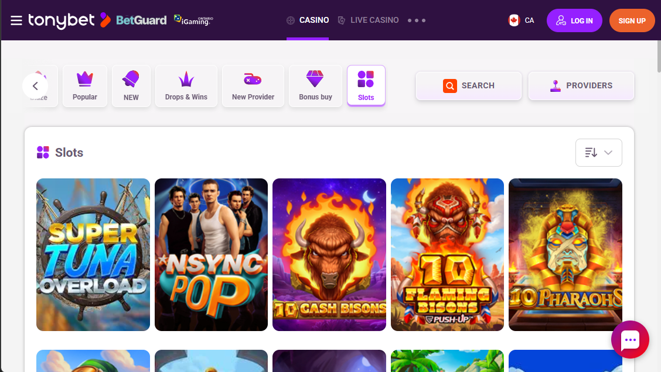
TonyBet’s game selection heavily leans on slots.During our research, we found more than 2,335 high-quality options. The full slots library is accessible from the games menu at the top of the main page. But for those more interested in sub-categorization, the main games lobby has listed options like Blaze, Popular, New, Bonus Buy, Drops & Wins, and New provider.
After spending quite some time exploring the slots collection at TonyBet Ontario, I discovered there were no progressive slots. But I did enjoy several fan-favorites, including The Big Dog House, The Book of Dead, Money Train 2, Gates of Olympus, and Reactoonz Blitzways. I also found a little over 10 non-progressive jackpots, such as Wazdan’s 16 Coins x5000, using the search tool.

New Slots Added This Month
TonyBet Ontario regularly adds new titles to its slots collection. The lobby even has a dedicated ‘New’ tab that features the latest additions. At the time of writing this TonyBet Ontario Casino review, there were over 210 new titles featured in this category.

Table Games
There’s no dedicated table games tab at TonyBet Casino Ontario. While you can use the search bar and type various table game types, this simply filters games with that specific searched word, which will also include live casino options.
In contrast, most Ontario online casinos like All Slots Casino showcase RNG-based table games in a clearly labelled section. You’ll even find subcategories like blackjack, roulette, video poker, baccarat, and sic bo, for faster browsing.
While exploring TonyBet Ontario’s games lobby, I only came across Atlantic City Blackjack Gold Series, American Roulette, and Baccarat, and that’s after using the filtering options.

Live Casino
TonyBet’s Ontario live casino hosts 350+ options ranging from live blackjack, live baccarat, live roulette, live hosted game shows, and VIP tables. Top-tier industry names like Evolution Gaming and Playtech power this section.
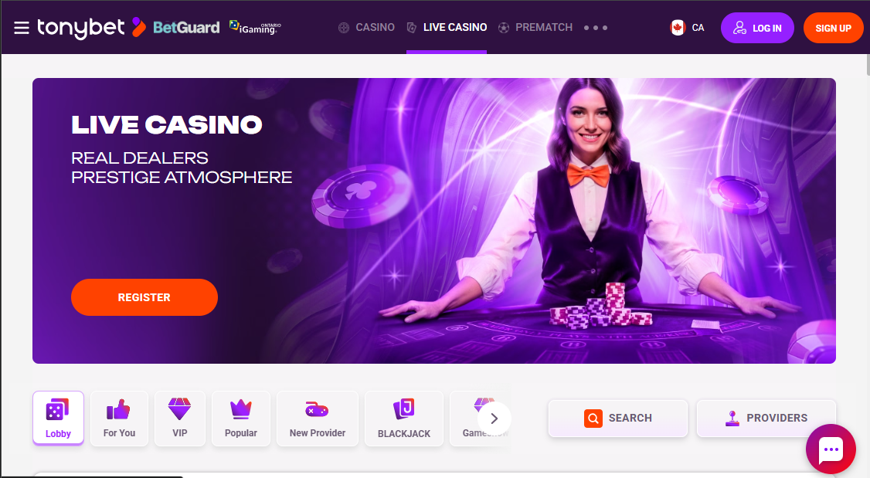
I found the live dealer blackjack section especially captivating, not just for its variety (280+) but also for the flexible bet limits. I could place bets from as low as $0.10 all the way to $5,000, catering to both casual bettors and highrollers. Pair this with the crisp HD streams, professional human dealers, and real-time interactions via live chat, and TonyBet Ontario easily delivers one of the most immersive and engaging live gaming sessions to Ontario players.

Banking Methods - Deposits and Withdrawals
Although limited, TonyBet Ontario Casino offers several Ontario-friendly methods to fund and withdraw from your account. Transaction speed depends on the choice of payment option, with e-wallets offering faster processing than credit or debit card options. But TonyBet doesn’t charge extra for processing.

Deposit Options
Ontario players can fund their TonyBet account using:
- Visa
- MasterCard
- Interac e-Transfer
- MuchBetter
The minimum deposit amount is $10, but maximums can go up to $4,000, depending on the payment option. There was also a $20 activation fee for using any new payment method. All deposits are free and arrive instantly.

Withdrawal Options & Speed
All deposit methods also work for withdrawals at TonyBet Ontario Casino. The least you can withdraw is $10, which is very convenient for players who prefer smaller payouts. As for maximum limits, they vary depending on the payment option. But the casino restricts withdrawals from exceeding past $4,000 daily, $15,000 weekly, and $50,000 monthly.
Processing times range from 12 hours for Interac payouts to seven business days for Visa/MasterCard withdrawals. But you must have completed account verification for a seamless cashout.

Ontario-Specific Payment Notes
While TonyBet Casino Canada supports a whole bunch of payment methods, the Ontario-facing platform only offers four local payment options. Interac, arguably the most popular option in Ontario, is the fastest for cashouts at TonyBet Ontario. The casino also doesn’t charge extra for all its transactions. But you may incur extra processing fees from the service provider. All transactions on TonyBet ON are in Canadian dollars.

Payment Methods, Limits, and Processing Fees

Method | Min. Deposit | Min. Withdrawal | Processing Time
Visa | $10 | $10 | Up to 7 days
MasterCard | $10 | $10 | Up to 7 days
Interac | $10 | $10 | Up to 24 hours
MuchBetter | $15 | $10 | Up to 24 hours

Mobile Experiences & Apps
TonyBet Casino is a prime choice for Ontario players who want to play casino games on the go. Beyond its browser-friendly site, it also offers dedicated apps for iOS and Android devices.

Mobile Website Performance
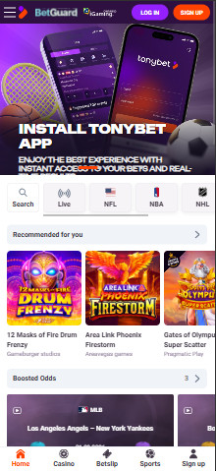
After testing the TonyBet Casino browser site first-hand on my Apple device, I found that the mobile site was easy to navigate with the same functionality as on desktop. I was able to deposit, withdraw, and contact support the same way as I did on desktop, just on a smaller screen. I experienced no lags or freezes while using the TonyBet Ontario Casino app.

Native App vs. Browser
Alongside the mobile website, TonyBet also offers a dedicated Android and iOS app for gaming on the go. Both apps are available for download via the respective App stores.
Notably, the TonyBet app carries modest ratings on both the Google Play Store (3.0/5 stars) and the App store (2.5/5 stars). That said, everything ran smoothly on the standalone app, but navigating the game library felt a bit slower than what I experienced on desktop and the mobile site.

Game Selection on Mobile
All the 2,500+ games available on TonyBet Ontario are mobile-optimized. While the variety doesn’t change, I would recommend using the mobile website for a more responsive and seamless experience. You may also need to flip your mobile screen to landscape mode for better visuals when playing live casino games.

Customer Support - Availability and Quality
TonyBet Ontario offers round the clock support services via email and live chat. Players are free to reach out with queries and complaints at any time.

Support Channels
Ontario players can get in touch with TonyBet’s customer support desk via:
- Live chat
- Email: info@tonybet.ca
- Webform on the site’s ‘Contact Us’ page
On top of that, there’s a fairly large FAQ section, which stands as a useful first point of reference when you need help figuring out how different features on the site work. But if you don’t find the answers you need here, live chat is perfect for instant responses. The webform also makes it easy to send emails, although the site promises a 24-hour response time.
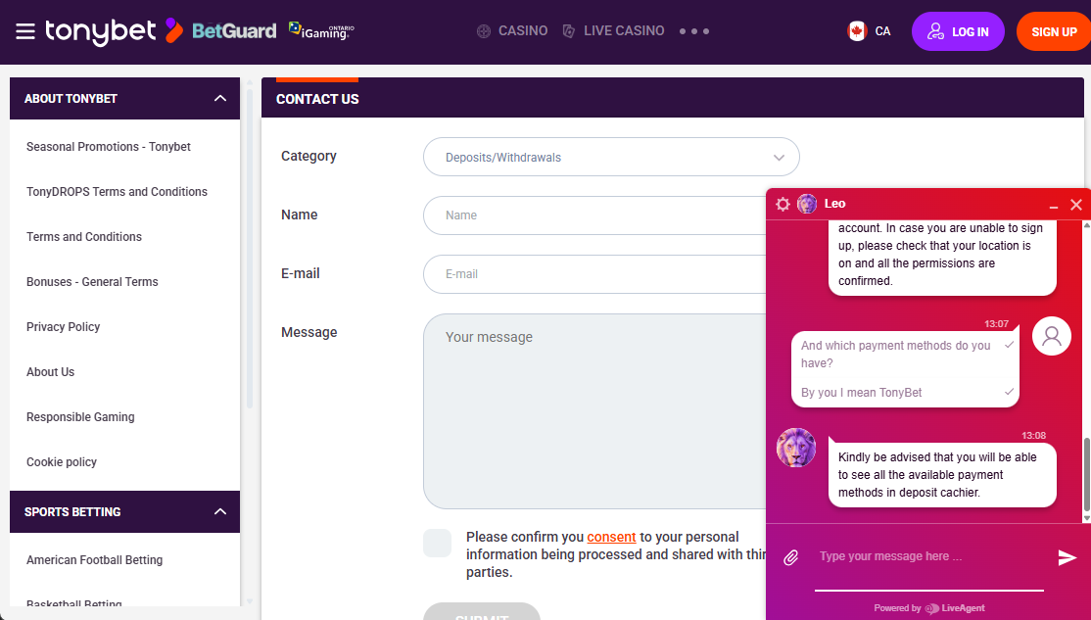

Support Quality Test
I reached out to TonyBet’s customer support desk with a query about its payment options. During testing, a customer support rep joined our live chat within a minute. The responses I received were professional, but soon became vague, deflective, and mixed with a few grammatical errors. I also used the webform whereby I received a detailed and helpful response within 18 hours.

Security, Fairness, & Responsible Gambling
Ontario players have nothing to worry about when playing at TonyBet Casino as everything, from licensing to onsite security to responsible gambling support, checks out. Notably, with more than two decades of experience in regulated gambling markets, this platform is as reliable as can be.

Licensing & Regulatory Compliance
TonyBet Ontario meets all the regulatory requirements set by the Alcohol and Gaming Commission of Ontario (AGCO) and has signed an operational agreement with iGaming Ontario. It holds a valid Ontario iGaming license under number OPIG1239101. On top of that, TonyBet Casino Canada is available all across Canada using its Kahnawake Gambling Commission license.

Responsible Gambling Tools
A thorough suite of responsible gambling tools is also available on TonyBet Casino, a good sign the brand cares about player health. In accordance with Ontario gambling regulations, TonyBet players can set deposit limits, loss limits, session reminders, time out, and self-exclusion. What’s more, players can get professional help through third-party links to Connex Ontario, the Responsible Gambling Council, and more.

Fair Play & Game Integrity
All games available at TonyBet Ontario are independently audited by BM Certification. This ensures all game results are fair and random, and that the return-to-player (RTP) rates are accurate. Also, TonyBet Casino games all come from reputable software providers such as Pragmatic Play, Games Global, and Evolution Gaming, all licensed and regulated in Ontario.

How Does TonyBet Casino Ontario Compare?

Feature | TonyBet Ontario | Betway Casino | Amazon Slots
Game count | 2,500+ | 1,500+ | 800+
Mobile app | Yes (iOS and Android) | Yes (iOS & Android) | No
Min deposit | $10 | $10 | $10

My Final Verdict: Should You Sign Up at TonyBet Casino Ontario?
TonyBet Casino is worth checking out if you’re in Ontario. It has an AGCO license and the large, regularly updated game library means there’s always something to explore. While progressive jackpots are missing and the number of table games are far and in between, TonyBet supports seamless gaming on the move through its standalone apps and mobile site, offers Ontario-friendly payment options, and delivers 24/7 support. All in all, there’s plenty to enjoy here as an Ontario casino player.

FAQs

Is TonyBet regulated in Ontario?
Yes. TonyBet holds a valid license in Ontario and operates under a signed agreement with iGaming Ontario. That means it meets the minimum standards of fairness, security, and player safety as required under Ontario gambling laws.

How quickly does TonyBet Casino payout in Ontario?
Payout times vary depending on the payment option used. During testing, Interac was the fastest payout option, taking up to 12 hours. But Visa and MasterCard can go up to seven days.

What types of games can I play at TonyBet Ontario?
TonyBet Casino offers diverse game types, the main ones being slots and live casino options. While there are no progressive jackpots and the game tables are few, you’ll also find a few non-fixed jackpot options.

What is the least amount you can deposit and withdraw at TonyBet Ontario?
You can deposit and withdraw a minimum of $10 from your TonyBet ON account. Deposits are instant but payouts can take up to seven days based on the cashier option used.

How do I contact TonyBet Casino in Ontario?
Ontario players can reach TonyBet Casino’s support desk via live chat (available 24/7) or via email at info@tonybet.ca. You can also use the web contact form available on the official website.
Please play responsibly. If you need support, contact ConnexOntario at 1-866-531-2600.

